**Ideation Phase**

**Empathize & Discover**

|  |  |
| --- | --- |
| Date | 30 June 2025 |
| Team ID | LTVIP2025TMID37158 |
| Project Name | Transfer Learning-Based Classification of  Poultry Diseases for Enhanced Health Management |
| Maximum Marks | 4 Marks |

**Empathy Map Canvas:**

The empathy map for the project *“Transfer Learning-Based Classification of Poultry Diseases for Enhanced Health Management”* focuses on understanding the challenges and needs of poultry farm owners. These individuals often struggle to identify diseases in their birds at an early stage due to limited technical knowledge and a lack of access to timely veterinary care. They frequently express frustration over the difficulty of recognizing symptoms and the cost and delay involved in consulting a vet. Many poultry farmers think about how early detection could save their livestock and reduce financial losses, yet they feel helpless due to their reliance on traditional and ineffective methods.

**Example: Poultry disease prediction**

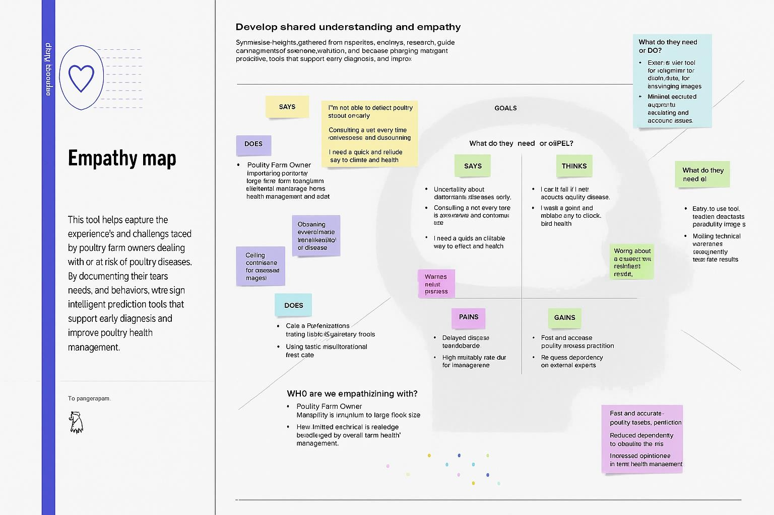

Visually, they observe birds showing abnormal behavior but cannot easily diagnose the disease. They hear from fellow farmers about new technology-based solutions and successful use of image-based disease detection tools. Despite this, they often continue to manually inspect birds or wait until the condition worsens before seeking help. Their major pains include delayed diagnosis, high mortality rates, and heavy dependence on external veterinary support. However, their goals and expectations revolve around finding a fast, reliable, and easy-to-use tool that can detect diseases through images. The potential gains include early disease prediction, reduced reliance on veterinarians, improved poultry health management, and increased confidence in their ability to handle issues independently.

This empathy map highlights the emotional and practical realities of the users, which are essential for designing an effective and user-friendly AI-based disease prediction system.